MLC mock answers

Multiple choice

- c
- d
- d
- a
- c
- b
- a
- c
- a
- d
- d
- c
- b
- a
- d
- a
- c
- d
- b
- c
- b
- b
- d
- c
- a

section 2

Question 26
a) when bottle opened the pressure drops the system tries to oppse change and increase pressure by favouring the reverse reaction producing CO2(g)
(the system is not likely to reach equilibrium as it is not a closed system)

b) to maximise ‘fizz’ you want as much CO2(aq) as possible before the drink is opened -the forward reaction is exothermic and this is the reaction that si favoured when temperature is decreased
Question 27
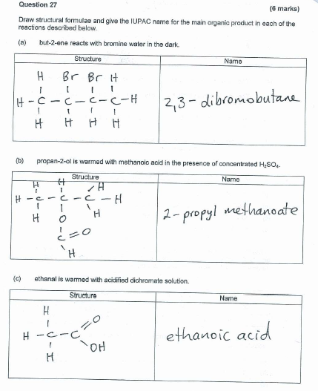
Question 28
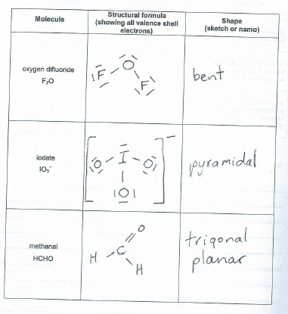

Question 29 (6 marks)
Place each of the following substances in the appropriate column based on the most significant type of intermolecular force present.
CH₃CH₂F PCl₃ NH₃ SiF₄ SO₃ N₂ CH₃OH
dispersion | dipole-dipole interactions | hydrogen bonding
SiF₄  SO₃  N₂ | CH₃CH₂F  PCl₃ | NH₃  CH₃OH
Question 30 (7 marks)
In the process of analysing a sample of cassiterite to determine the tin content, the tin is extracted as Sn²⁺ ions. A titration was performed by adding 0.0170 mol L⁻¹ potassium dichromate solution to an acidified solution of Sn²⁺ extracted from a 0.750 g sample of the ore.
3Sn²⁺(aq) + Cr₂O₇²⁻(aq) + 14H⁺(aq) → 3Sn⁴⁺(aq) + 2Cr³⁺(aq) + 7H₂O(l)

The table below shows the volume required to reach the equivalence point.

 | 1 | 2 | 3
Final volume K₂Cr₂O₇(aq) mL | 25.65 | 38.05 | 27.00
Initial volume K₂Cr₂O₇(aq) mL | 3.00 | 16.61 | 5.58
titre mL | 22.65 | 21.44 | 21.42

(a) Explain what is meant by the term equivalence point. (1 mark)

The point when you have stoichiometrically equivalent amounts of both reactants
(b) Complete the table above and calculate the average titre. (2 marks)
Average titre 21.44 + 21.42 /2 == 21.43mL
- percentage by mass Sn in sample
v Cr₂O₇²⁻ = 21.43mL c = 0.017
n Cr₂O₇²⁻ = cv = (0.017)(0.02143) = 0.000364mol
n Sn²⁺ = 3/1 x n Cr₂O₇²⁻ = 3 x 0.000364 = 0.00109mol
n Sn = nSn²⁺ = 0.00109mol
mass Sn = 0.00109 x 118.7 = 0.1297g
% Sn = 0.1297/0.75 x 100 = 17.3%

Question 31
Sr(OH)₂ → Sr²⁺ + 2OH₋
0.02 0.04M
[H+] = 1 x 10⁻¹⁴ /[OH-]=1x10⁻¹⁴ /0.04= 2.5 x 10⁻¹³
pH = -log 2.5x10⁻¹³ = 12.6

Question 32 (10 marks)

(a) Complete the table below, giving expected observations for reactions described. If no reaction occurs or no change is observed say ‘no visible change’
(6 marks)

Procedure | Does a reaction occur? | Observations
strontium metal is added to water at 25°C | yes | Silver solid added to colourless soln and colourless odourless gas formed
copper(II)nitrate solution and sodium chloride solution are mixed | No (really yes but it is off syllabus) | Blue solution is added to colourless solution and green solution forms (may accept blue soln forms)
acidified potassium permanganate solution is mixed with a solution of hydrogen sulfide | yes | Purple solution is added to colourless solution and a yellow solid forms, colour of purple solution fades

b) give equations for any reactions that occur

Sr + H₂O → Sr²⁺ + H₂ + 2OH⁻

2MnO₄⁻ + 6H⁺ + 5 H₂S → 2Mn²⁺ + 8H₂O + 5 S

Question 33
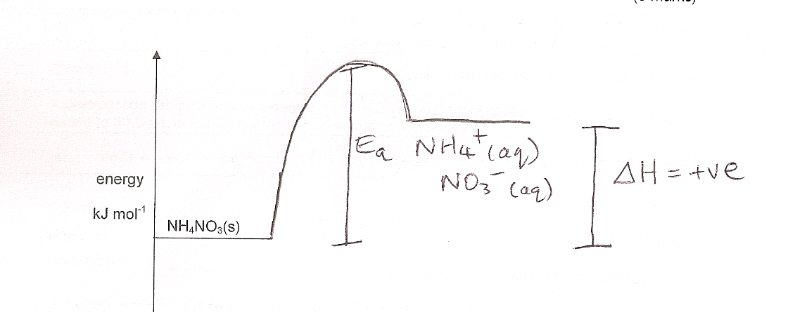
b) activation energy is the minimum energy needed for a collision to result in a reaction

b) i) NH₄⁺ + H₂O(l) ↔ NH₃ + H₃O⁺

(ii) K = [NH₃][H₃O⁺]
[NH₄⁺]

- something that instantly drops backward reaction ie drops conc of species on right side of arrow
this would include addition of NaOH as it would react with H₃O⁺

- value of equilibrium constant would be the same as temp has not changed so K can’t have changed

Question 34
There has been a mix up with labelling in the chemical store. The technician must carry out some distinguishing tests to confirm the identity of some compounds.

In the table below give your recommendation for a simple test the technician can carry out to confirm which is which for the following pairs of substances

Chemicals to be identified | Distinguishing test | Observations
solid ammonium carbonate  and  solid ammonium chloride | Add dilute HCl | ammonium carbonate  would fizz ie produce bubbles
solid ammonium carbonate  and  solid ammonium chloride | Add dilute HCl | ammonium chloride  no fizz or bubbles
dilute nitric acid  and  dilute hydrochloric acid | Add silver nitrate solution | nitric acid  two colourless soln mix to form colourless soln
dilute nitric acid  and  dilute hydrochloric acid | Add silver nitrate solution | hydrochloric acid  white ppt forms

Question 35
Complete the table below by giving the name or chemical formula of a species that matches the description given.

Description | Name or formula
a primary standard used in redox titrations | H₂C₂O₄
the conjugate acid of ammonia | NH₄⁺
a substance that, when in aqueous solution, is suitable for use in the salt bridge of an electrochemical cell | NaNO₃
a substance that exists as discrete molecules | H₂
a strong diprotic acid | H₂SO₄
a material suitable for use as an inert electrode | Graphite or platinum

Question 36
Consider the following reaction at equilibrium.

SO₂(g) + NO₂(g) SO₃(g) + NO(g) + 42 KJ

Complete the table below, which describe changes made to the system. (6 marks)

Change made | Rate of reverse reaction when equilibrium re-established  increases/decreases/no change | moles of NO compared with original equilibrium  increases/decreases/no change
pressure is increased | increased | No change
catalyst is added | increased | No change
decreasing the concentration of NO₂ | decreased | decreases

Section 3

Question 37
a) Equation 2Cr³⁺(aq) + 3S²⁻(aq) → Cr₂S₃(s)
observation
a deep green solution is added to a colourless solution and a green solid forms
b)
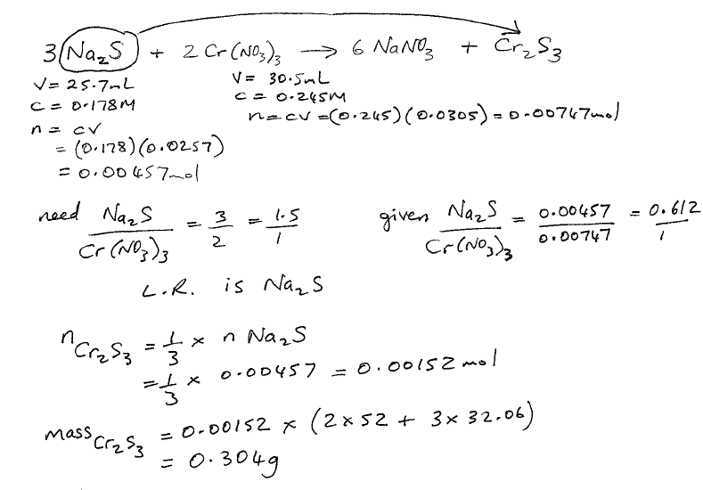

Question 37
- phenolphthalein
- benzoic acid is a weak acid because the equivalence point is basic, this indicates that C6H5COO- will hydrolyse in water to form OH- ions (anions derived from strong acids do not do this)
- when 10mL of naOH has been added you are not yet at equivalence point and still have reasonable amounts of benzoic acid which reacts with NaOH holding pH steady once all the benzoic acid has reacted there is nothing to absorb OH- and so pH increases

d)
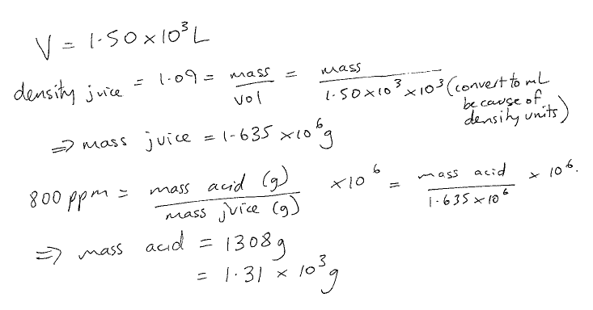

Question 38
- i) Cd
ii) NiO(OH)
iii) 2NiO(OH) + 2H₂O + Cd → Cd(OH)₂ + 2Ni(OH)₂(s)
- 1.3 V
- No hydroxide ions are produced and consumed in reaction so no change to[H⁺] and so no change to pH
- Products kept in close proximity to electrodes

b)
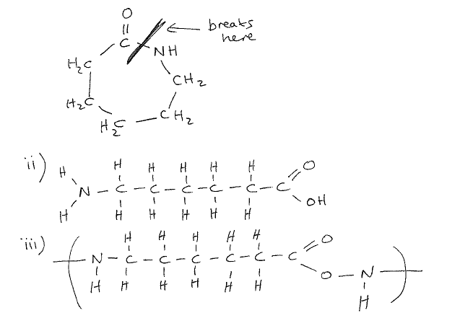
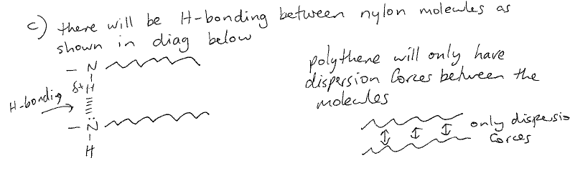

Question 39
a)
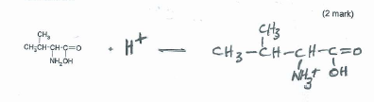
- the conductivity in solution suggests presence of charged particles in solution, this suggests some ionic bonding (be careful I think this would still be classified as a covalent molecular substance ?? check)

ii)
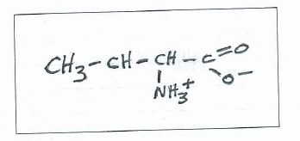
d) i)
qualitative means they investigate reactions to determine properties and hence structure
quantitative means numerical data is collected to help determine molar mass etc

ii)
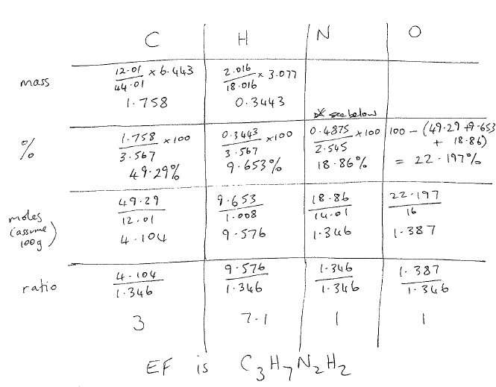
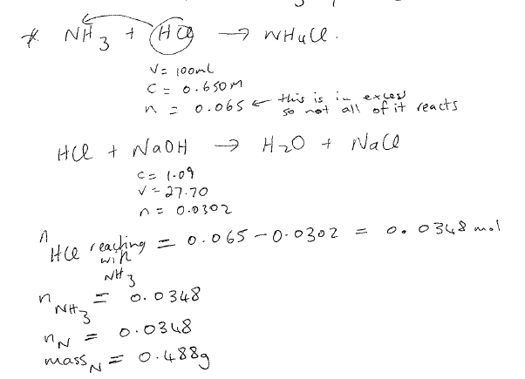
iii)
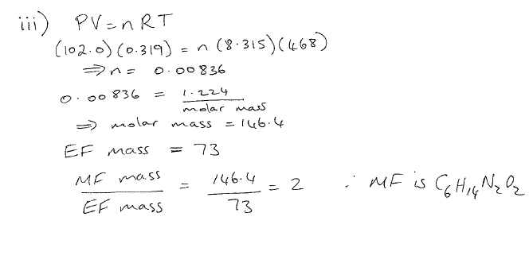Question 40
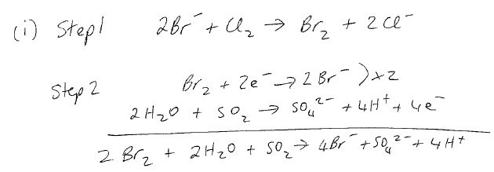
ii) the Br- ions in seawater are in very low concentration and the steps are needed to concentrate th Br-
iii) it is used in car batteries and in the manufacture of fertilisers

b) increase in boiling points of halogens down the group is due to increased dispersion forces resulting from larger molecules with more electrons

ii) HF has higher boiling point than other hydrogen halides as H-bonding is present between HF molecules whereas the other hydrogen halides do not have H-bonding
the steady increase in boiling point after HF is due to increased dispersion forces

- i) it contains a double or triple bond
ii) saturated

the Br₂ dissolves in hydrocarbon layer after shaking because the dispersion forces between the Br₂ molecules and hydrocarbon molecules are sufficiently strong to overcome the dispersion forces between the Br2 molecules and the dispersion forces between the hydrocarbon molecules

d)
